SIMATS ENGINEERING (SAVEETHA SCHOOL OF ENGINEERING)
Department of Computer Science and Engineering

ASSESSMENT TOOL 2 – Concept Mapping

Course Code: | CSA0305 | Course Title: |  | Data Structures  Assessment Tool 2 – Concept  Mapping  100
 | CO1 – Imitation (BL3, BL4)
CO Assessed: |  | Assessment:
 | 35% of CIA
Weightage: |  | Total Marks:
CO1 Statement: | Apply suitable data structures and ADTs for efficient problem solving by analyzing time and space complexity.
Student Name: | i.jaswanth |  | Reg. No.: | 192525345  10/07/2026
 | AI&ML
Section / Batch: |  |  | Date:

Code of Conduct
I i.jaswanth(192525345) (Name / Reg No) certify that this submission is my original work and that I have adhered to the guidelines specified for this assessment. I understand that any violation of academic integrity rules will result in disciplinary action. Signature of the Student: i.jaswanth

Instructions
- This test contains 5 Concept mapping questions. Total: 100 Marks.
- When a student answer using a concept map, in evaluation the answer should be with following four requirements: Understanding of concepts, Connections between ideas, Logical structure, Clarity of representation.
- No negative marking. Unanswered questions carry zero marks.

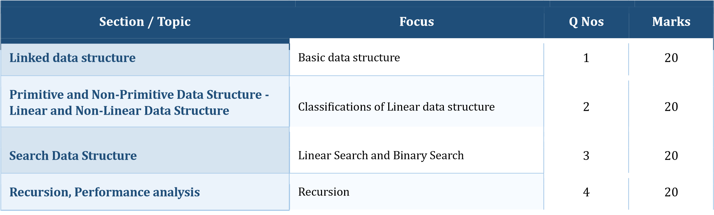
Tree Data Structures

Classifications of Tree data structure

5

20

GRAND TOTAL:

Marks
100

Annexure A – Concept Mapping

- A student attendance system records daily presence data. Construct a concept map linking Array → Fixed Size → Sequential Access → Linked List → Dynamic Allocation → Flexibility.
Explain how each structure works and justify which is more suitable for dynamic data
updates. (20 Marks)
- A weather monitoring system collects temperature, humidity, and wind data continuously. Construct a concept map linking Primitive Data Types → Non-Primitive Structures → Linear
Structures → Non-Linear Structures → Applications. Include examples and explain how each
structure supports continuous data processing. (20 Marks)
- A digital archive stores millions of documents. Construct a concept map linking Searching → Linear Search → Binary Search → Sorted Data → Time Complexity → Performance. Analyze the impact of data organization on search efficiency and justify the best technique.
(20 Marks)
- A program processes nested expressions using recursion and may encounter deep nesting. Construct a concept map linking Recursion → Call Stack → Stack Overflow → Error Handling → Efficiency. Analyze potential issues and justify strategies to handle them. (20 Marks) 5. A company maintains hierarchical employee records with multiple levels of management. Construct a concept map connecting Tree → Nodes → Levels → Traversal (DFS/BFS) → Searching → Efficiency. Analyze how traversal techniques affect performance and justify the most suitable approach for retrieving employee data. (20 Marks)
Rubrics for Calculation

Criteria | Weightage | Level 4 – Exemplary | Level 3 –  Proficient | Level 2 –  Developing | Level 1 –  Beginning
Understanding  of  Problem Context | 20 | Clearly understands the problem and accurately identifies all requirements | Good understanding with minor gaps | Basic understanding; some requirements unclear | Poor  understanding or misinterpretation of the problem
Application of Concepts | 30 | Accurately applies appropriate concepts to solve complex problems | Applies relevant concepts correctly with minor errors | Applies basic concepts with limited accuracy | Fails to apply appropriate concepts
Problem-Solving Approach | 20 | Logical, well- structured, and efficient approach | Mostly logical approach with minor gaps | Basic approach with some inconsistencies | Illogical or unclear approach
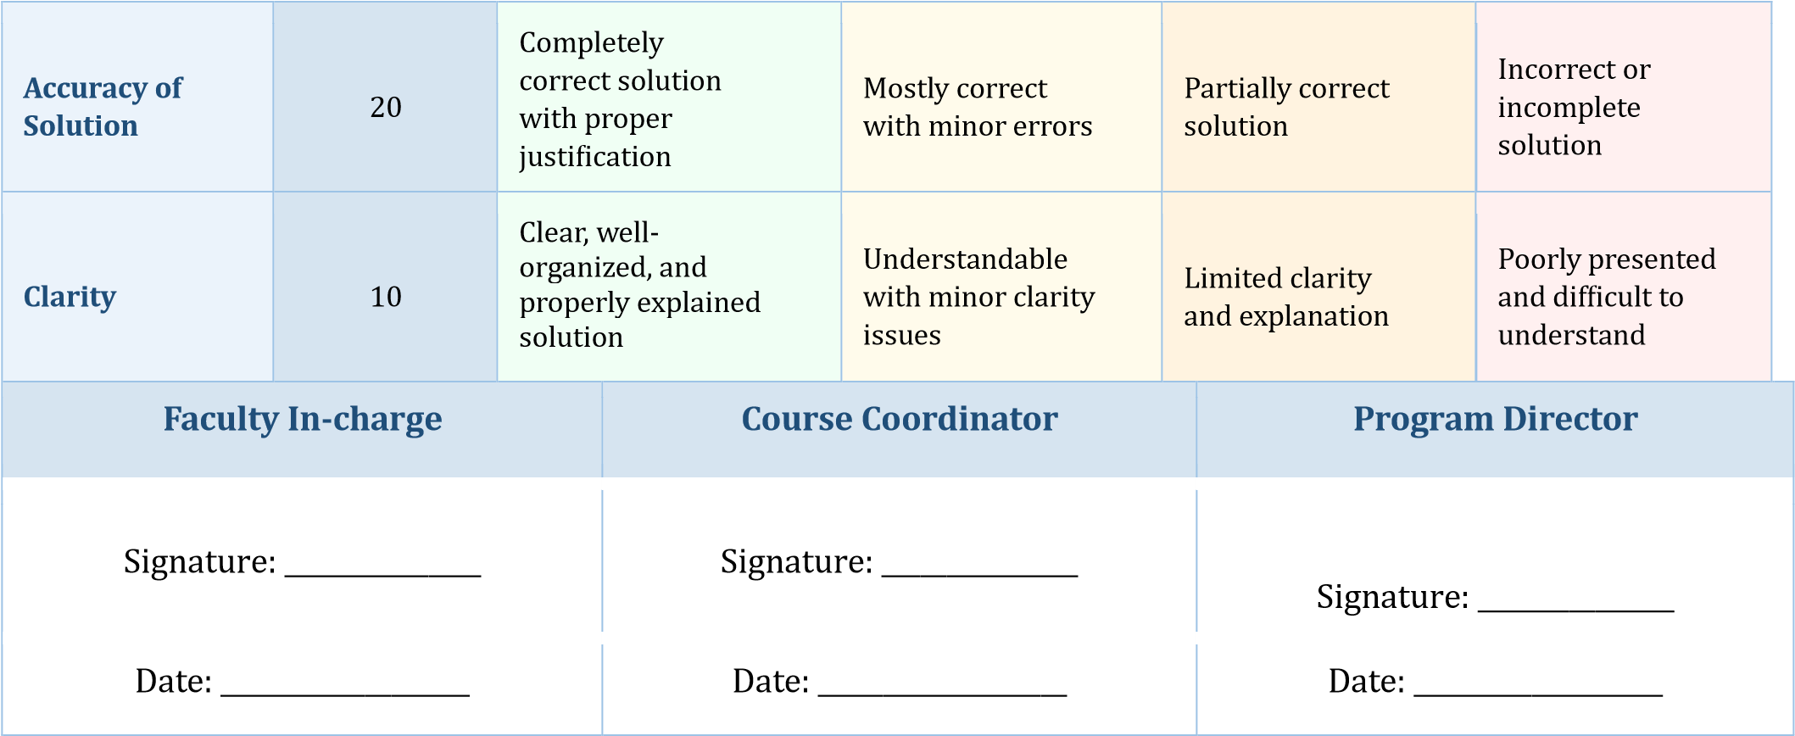

1
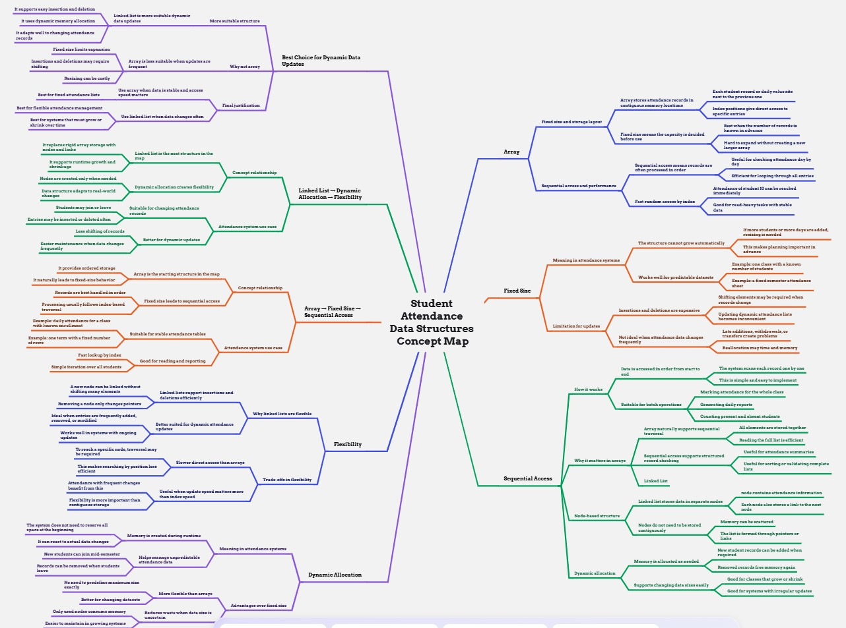

2:
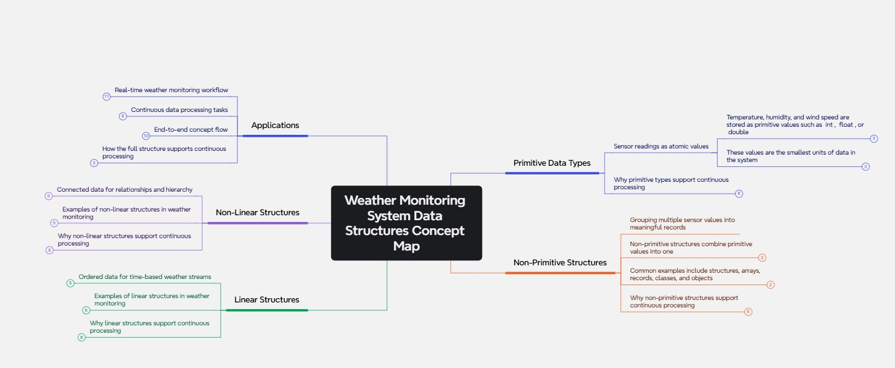

3:
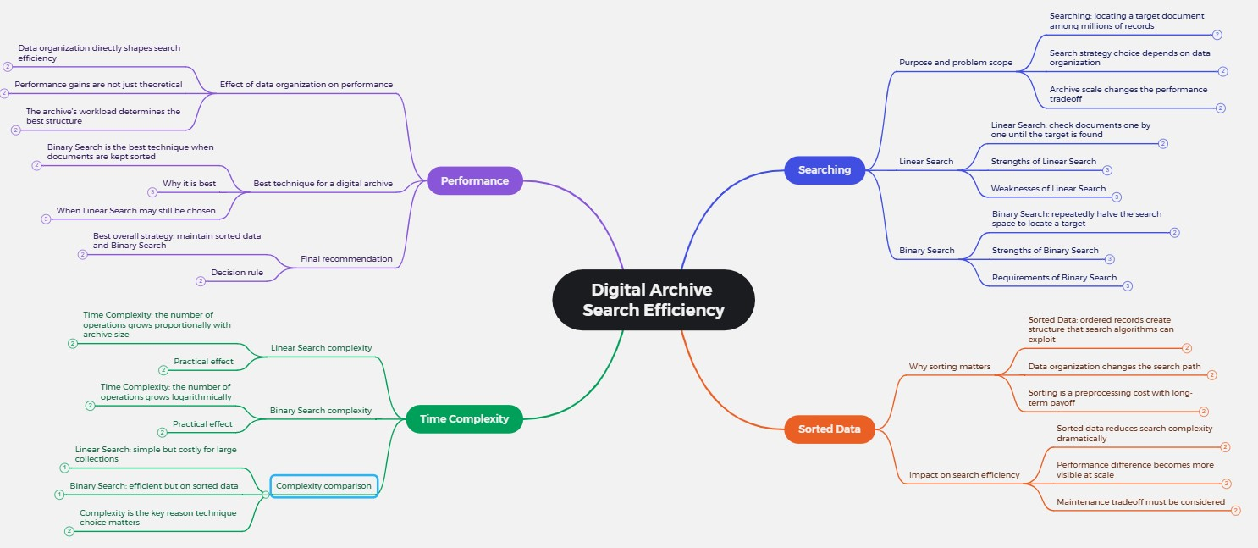

4:
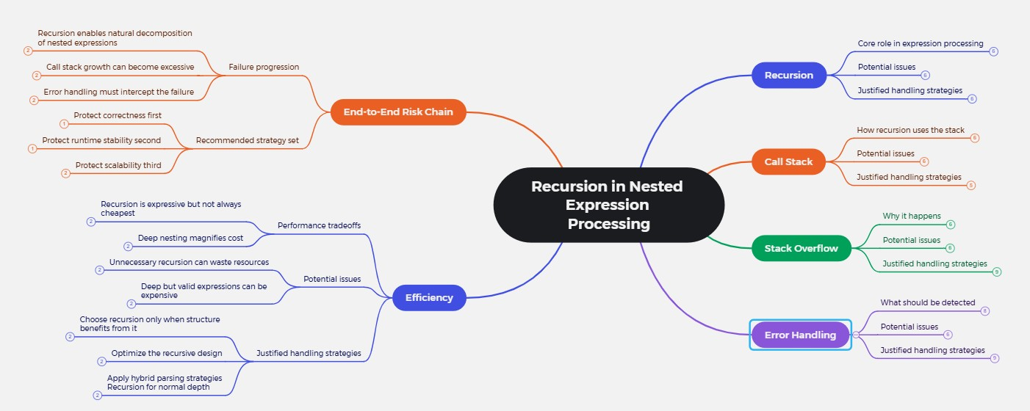

5.
